COMSATS UNIVERSITY ISLAMABAD, LAHORE CAMPUS



Name: Abdul Wahab

Registration No: FA22-BSE-160

Class: Object Oriented Programming

Assignment: Lab Assignment 4

Teacher: Mam Mamoona Tassaduq

Date: 30th May 2023

Question 1:

import java.io.*;  
import java.util.*;  
  
public class LabAssign4_Q1 {  
 public static void main(String[] args) {  
 Scanner scn = new Scanner(System.*in*);  
  
 try{  
  
 FileWriter writer = new FileWriter("input.txt",true);  
 PrintWriter writer1 = new PrintWriter(writer);  
  
 System.*out*.println("Enter Line 1 :");  
 String one = scn.nextLine();  
  
 System.*out*.println("Enter Line 2 :");  
 String two = scn.nextLine();  
  
 System.*out*.println("Enter Line 3 :");  
 String three = scn.nextLine();  
  
 System.*out*.println("Enter Line 4 :");  
 String four = scn.nextLine();  
  
 writer1.println(one);  
 writer1.println(two);  
 writer1.println(three);  
 writer1.println(four);  
  
 writer1.close();  
 //FILE CLOSED  
  
 //Taking a Variable to Count A  
  
 int aCounter = 0;  
  
 Scanner aScan = new Scanner(new File("input.txt"));  
  
 while (aScan.hasNext()){  
  
 String A = aScan.nextLine();  
  
 if(A.matches("A.*"));  
 {  
 aCounter++;  
 }  
 }  
 FileWriter aWriter = new FileWriter("output.txt",true);  
 PrintWriter awriter1 = new PrintWriter(aWriter);  
  
  
 awriter1.print(aCounter);  
  
 awriter1.close();  
  
 } catch (IOException e) {  
 throw new RuntimeException(e);  
 }  
  
  
 }  
  
  
}

OUTPUT:

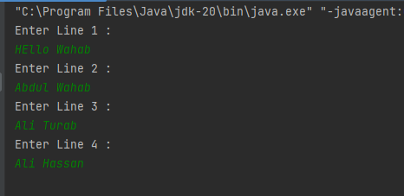

Input.txt:

Output.txt:

Question No 2:

import java.io.*;  
import java.util.*;  
  
  
public class LabAssign4_Q2 {  
  
 public static void main(String[] args) {  
 Scanner scn = new Scanner(System.*in*);  
  
 try{  
 //Creating Binary File to Store Data  
 FileOutputStream write = new FileOutputStream("data.bin");  
 DataOutputStream writer1 = new DataOutputStream(write);  
  
 //Taking Integers Input From User  
 System.*out*.println("Input 10 Integers: ");  
 for(int i=0;i<10;i++){  
 int numbers = scn.nextInt();  
 writer1.writeInt(numbers);  
 }  
  
 //Writing FIle Closed Here  
 writer1.close();  
  
 //Reading Binary File to Read Data For Max and Mini  
  
 FileInputStream input = new FileInputStream("data.bin");  
 DataInputStream input1 = new DataInputStream(input);  
  
  
 int[] arr = new int[10];  
  
 for(int i=0;i<10;i++){  
  
 arr[i] = input1.readInt();  
 //System.out.println(arr[i]);  
 }  
  
 int maximum = arr[0];  
 int minimum = arr[0];  
  
 for(int i=0;i<10;i++){  
 if (arr[i]>maximum){  
 maximum = arr[i];  
 }  
 if (arr[i]<minimum){  
 minimum = arr[i];  
 }  
 }  
  
  
 //for(int i=0;i<10;i++){  
  
 //}  
  
 input1.close();  
  
  
 System.*out*.println("Maximum Number is: "+maximum);  
 System.*out*.println("Manimum Number is: "+minimum);  
  
  
 } catch (FileNotFoundException e) {  
 throw new RuntimeException(e);  
 } catch (IOException e) {  
 throw new RuntimeException(e);  
 }  
  
  
 }  
  
  
}

OUTPUT:

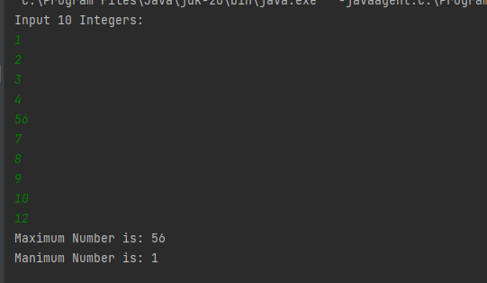

Question No 3:

import java.io.*;  
  
public class LabAssign4_Q3 {  
  
  
 public static void main(String[] args) {  
   
 //Giving Hardcoded Values of Product Here   
 Product p1 = new Product(1, "Product1", (double) 12.5);  
 Product p2 = new Product(2, "Product2", (double) 5.5);  
 Product p3 = new Product(3, "Product3", (double) 9.5);  
  
 //Serialization Here  
 try {  
 FileOutputStream out = new FileOutputStream("product.ser");  
 ObjectOutputStream out1 = new ObjectOutputStream(out);  
  
 out1.writeObject(p1);  
 out1.writeObject(p2);  
 out1.writeObject(p3);  
  
 out1.close();  
 out.close();  
  
  
 System.*out*.println("Serialized!");  
  
 } catch (FileNotFoundException e) {  
 throw new RuntimeException(e);  
 } catch (IOException e) {  
 throw new RuntimeException(e);  
 }  
  
 //DeSerialization Here  
 try {  
 FileInputStream input = new FileInputStream("product.ser");  
 ObjectInputStream input1 = new ObjectInputStream(input);  
  
 while (input.available()>0){  
 Product p = (Product) input1.readObject();  
  
 System.*out*.println("\n"+p);  
 }  
 input.close();  
 input1.close();  
  
 } catch (FileNotFoundException e) {  
 throw new RuntimeException(e);  
 } catch (IOException e) {  
 throw new RuntimeException(e);  
 } catch (ClassNotFoundException e) {  
 throw new RuntimeException(e);  
 }  
 }  
}  
class Product implements Serializable{  
  
 private int ProductId;  
 private String Name;  
 private double price;  
  
 public Product(int productId, String name, double price) {  
 ProductId = productId;  
 Name = name;  
 this.price = price;  
 }  
  
 public int getProductId() {  
 return ProductId;  
 }  
  
 public void setProductId(int productId) {  
 ProductId = productId;  
 }  
  
 public String getName() {  
 return Name;  
 }  
  
 public void setName(String name) {  
 Name = name;  
 }  
  
 public double getPrice() {  
 return price;  
 }  
  
 public void setPrice(double price) {  
 this.price = price;  
 }  
  
 //ToString Of Product  
  
  
 @Override  
 public String toString() {  
 return "Product{" +  
 "ProductId=" + ProductId +  
 ", Name='" + Name + '\'' +  
 ", price=" + price +  
 '}';  
 }  
}

OUTPUT:

